

**Intro to data science**

**VERSION CONTROL WITH GIT**

DEPARTMENT:

**SOFTWARE ENGINEERING**

SUBMITTED BY:

**SYEDA SAMANA BATOOL**

SUBMITTED TO:

**MAM MUNEEBA SIRSHAR**

**SIR ABEER NOOR RASHEED**

**MAM AYESHA**

ENROLLMENT NO:

**2017-BSE-066**

SEMESTER:

**VI-B**

SESSION:

**2017-2021**



**INTRODUCTION:**

This document contains all the screenshots of my git commits through out this project. This depicts that I have regularly commited my work from git bash to git hub repository.

**Creating an empty git repo:**

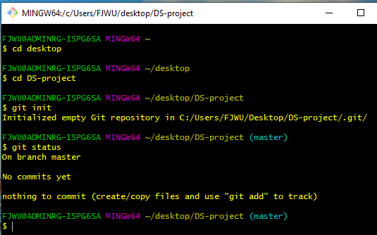

**Moving data cleaning files to that directory associated with git :**

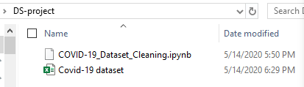

**Checking status again:**

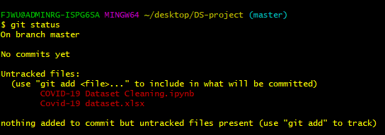

**Adding files & Commiting files:**

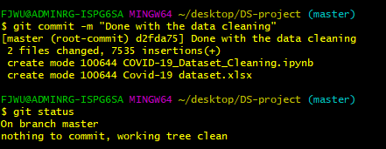

**Checking log:**

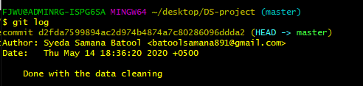

**Pushing files to git hub directory:**

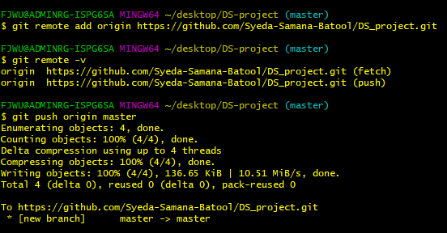

**Files pushed to github:**

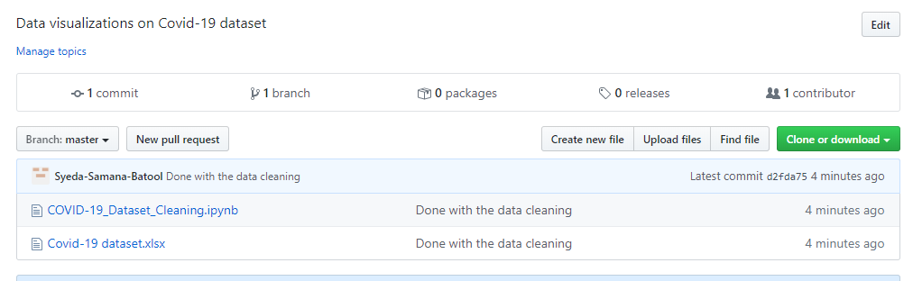

**Adding & Commiting my first Visual to git:**

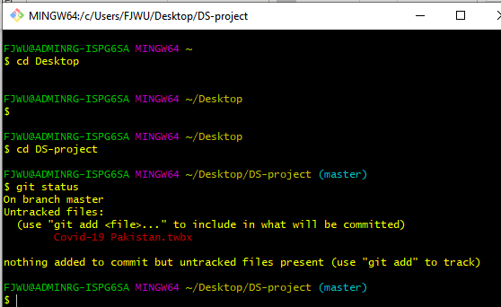

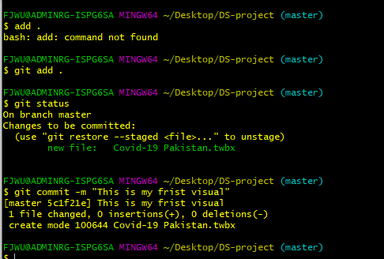

**Pushing my first visual to github:**

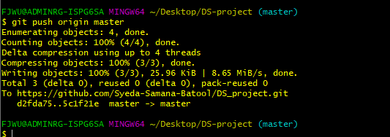

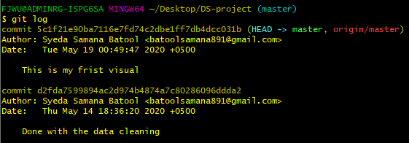

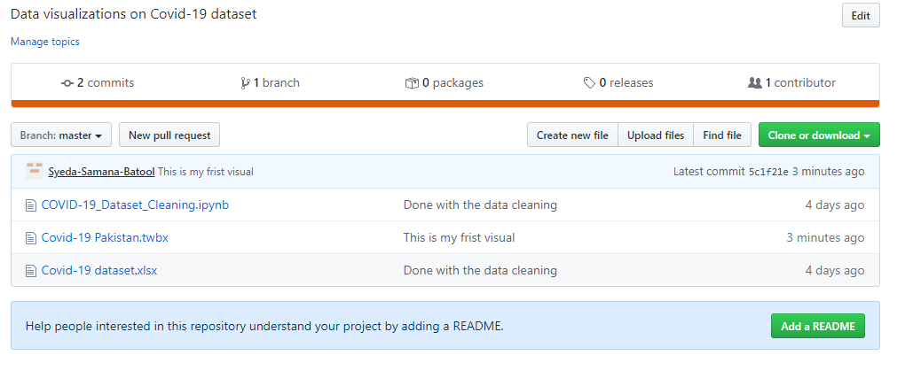

**My second Visual:**

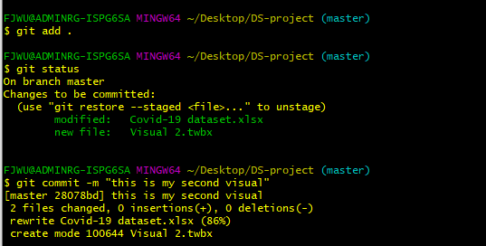

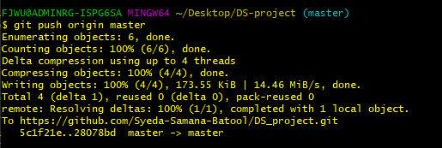

**Adding 3 more visuals:**

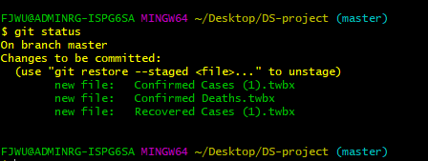

**Commiting them:**

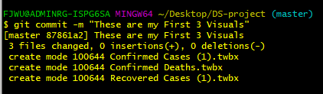

**Viewing Log:**

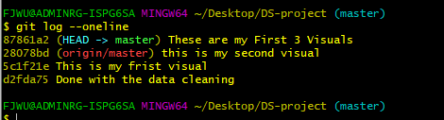

**Pushing into github:**

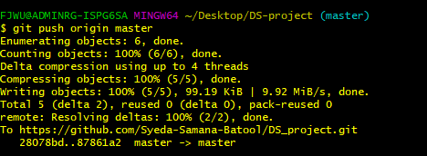

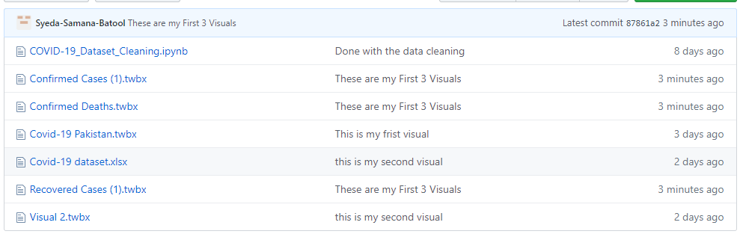

**FINAL COMMIT OF FIRST VISUAL:**

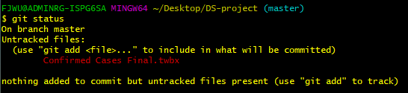

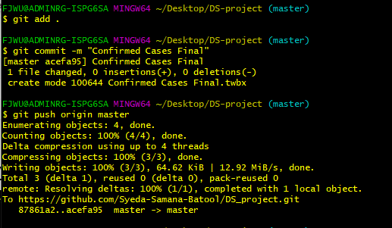

**FINAL COMMIT OF SECOND VISUAL:**

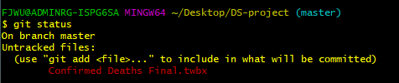

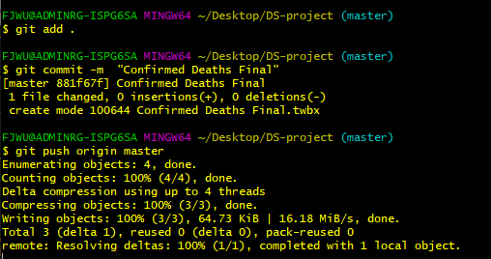

**FINAL COMMIT OF THIRD VISUAL:**

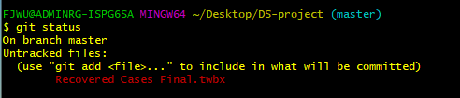

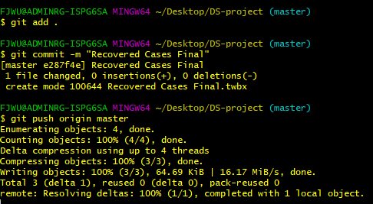

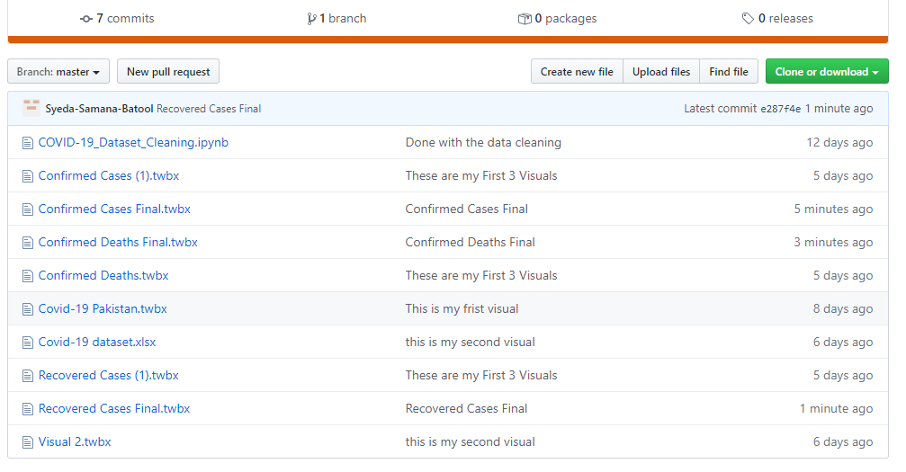

**Fourth Visual:**

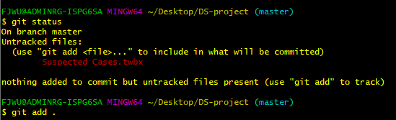

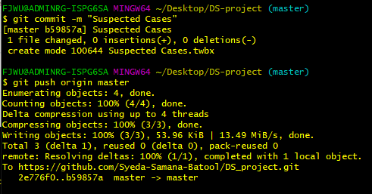

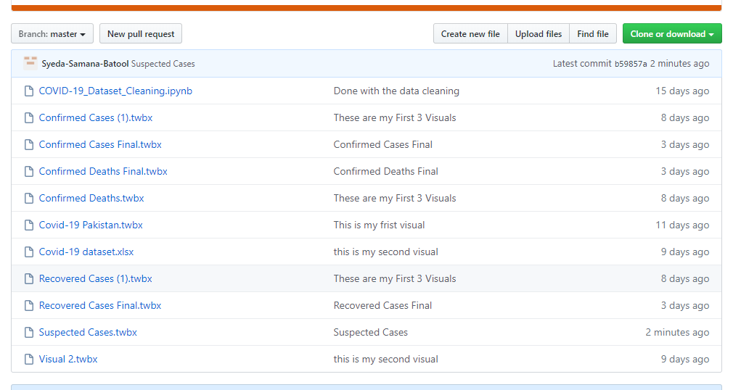

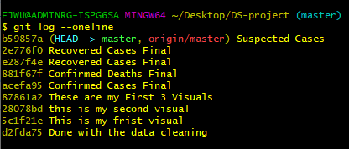

**5th Visual:**

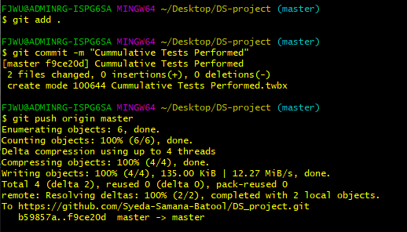

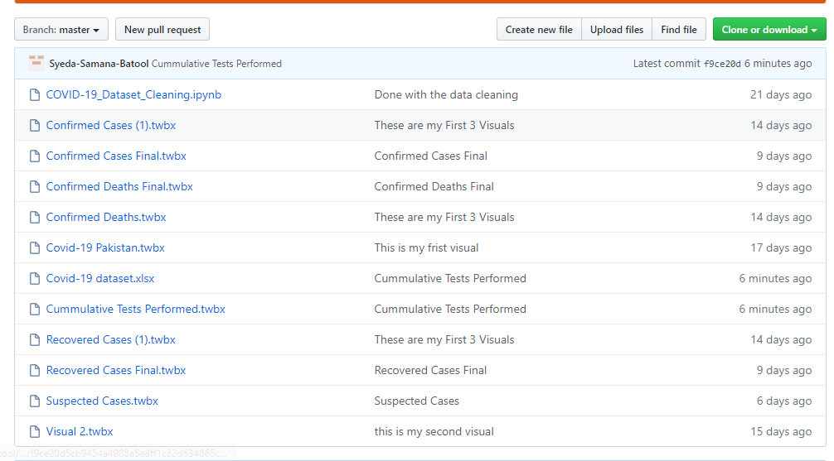

**Git log stat:**

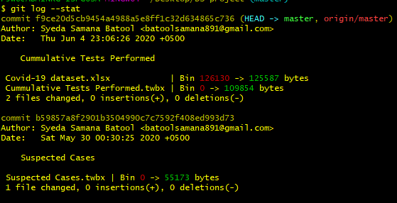

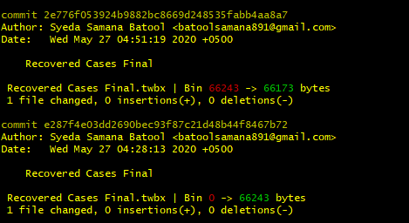

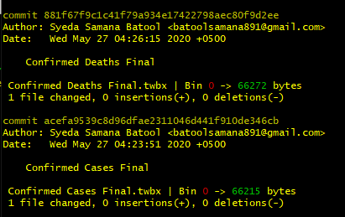

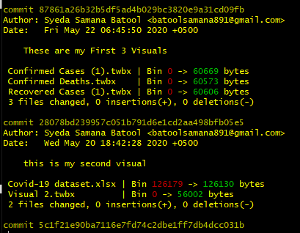

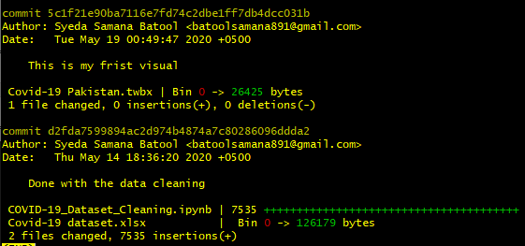

**6th Visual:**

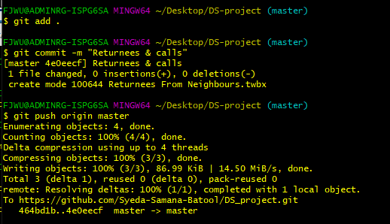

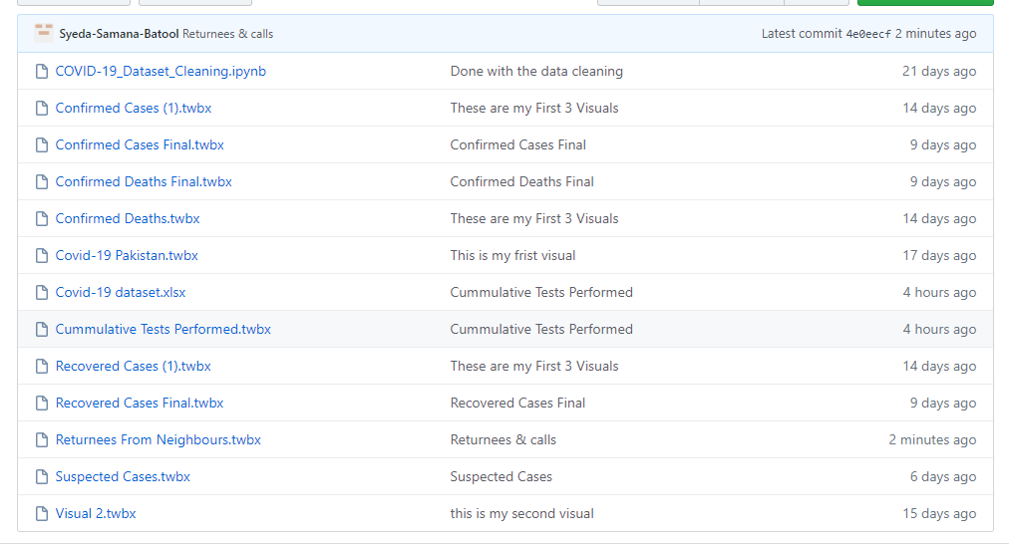

**7th Visual:**

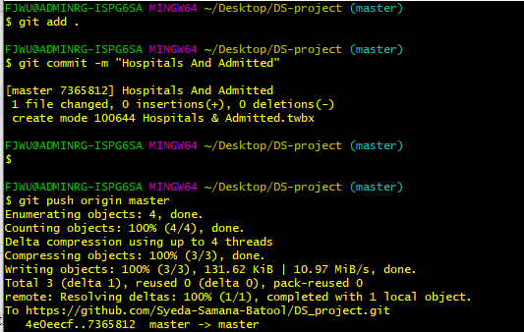

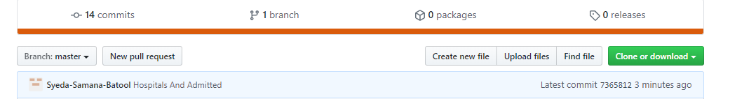

**8th Visual:**

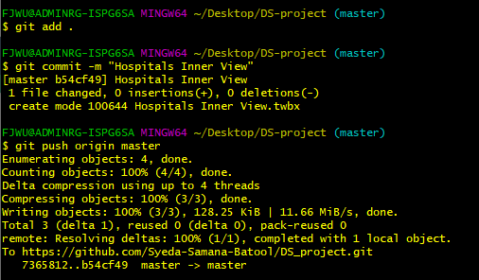

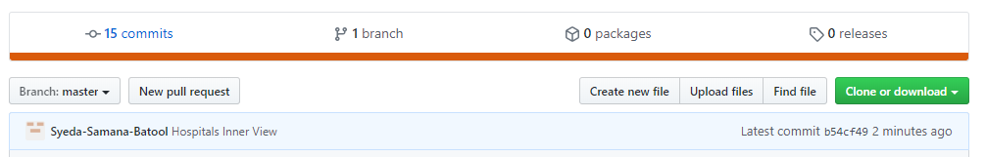

**9th Visual:**

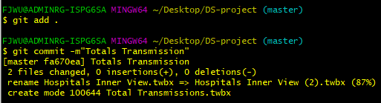

**10th Visual:**

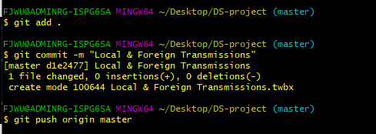

**Committing the folder having final versions of Dashboards:**

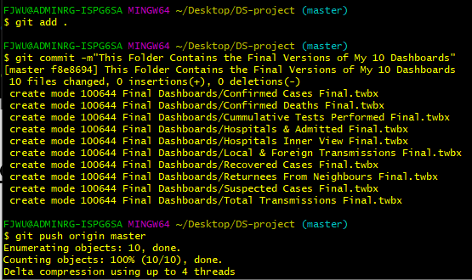

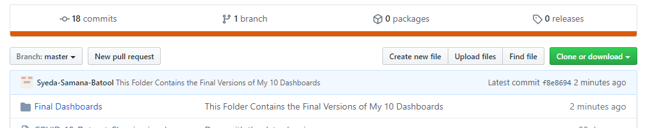

**Checking Final log and stats :**

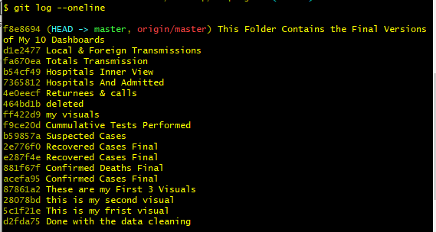

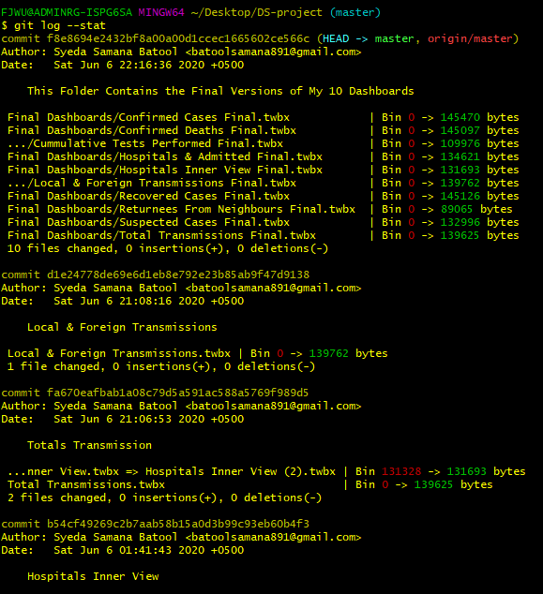

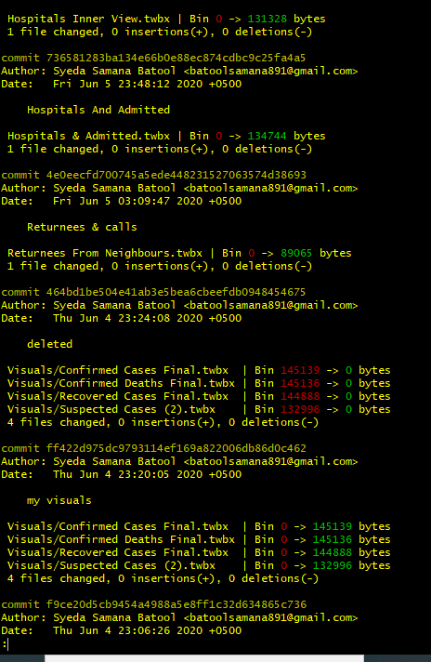

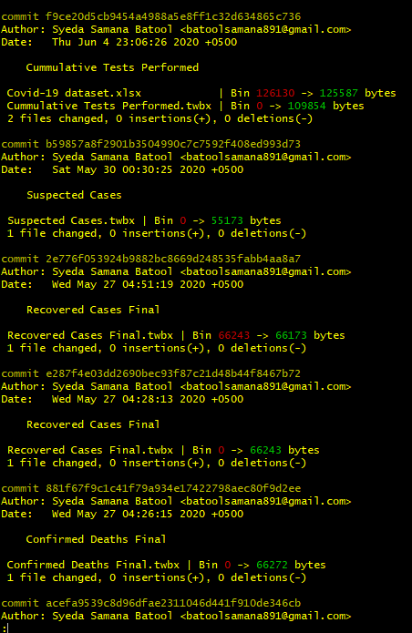

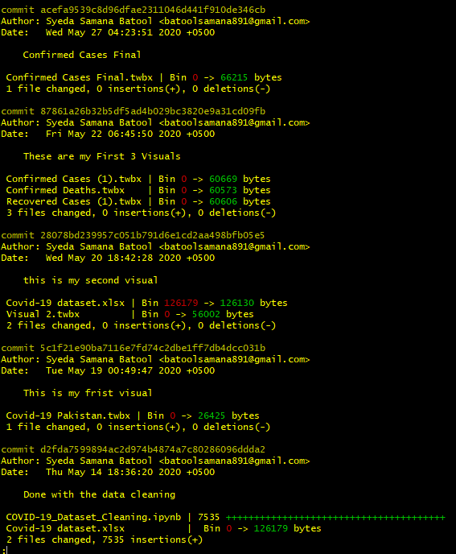

**Note**: I will upload my blog post directly into the github repository

**THE END:**